Corrie Anne Goldfinger 2008
http://qspace.library.queensu.ca/bitstream/1974/1426/1/Goldfinger_Corrie_A_200809_MSc.pdf

Vulvodynia Information Package

What is Vulvodynia?
Vulvodynia is defined as “vulvar discomfort, most often described as burning pain, occurring in the absence of relevant visible findings or a specific, clinically identifiable, neurologic disorder.” Vulvodynia affects an estimated 16% of women in the general population. There are two major types of vulvodynia that are based on pain location. The first is localized vulvodynia, in which pain is restricted to a portion of the vulva, such as the vestibule, as in vulvar vestibulitis syndrome (VVS). The second is generalized vulvodynia (GVD), in which the pain is more diffuse, involving the whole vulva.

1. What is vulvar vestibulitis syndrome (VVS; also called provoked vestibulodynia)?
VVS is the most common cause of dyspareunia (i.e., painful intercourse) in women of child-bearing age. A recent epidemiological study estimated that VVS affects 12% of pre-menopausal women in the general population. Women with VVS report experiencing a highly localized, burning and/or cutting pain at the entrance of the vagina (called the vulvar vestibule) during sexual intercourse, as well as during other activities that involve applying pressure to the vestibule (e.g., tampon insertion, gynecological exams). Although the pain of VVS typically disappears after pressure to the vestibule is removed, many women report lasting pain or discomfort after sexual intercourse or similar activities. Approximately 50% of women who suffer from VVS have what is called primary VVS, indicating that the pain has been present since their first intercourse attempt. The other half has secondary or acquired VVS, which develops after a period of pain-free intercourse, and in many cases, after an aggravating factor (e.g., repeated vaginal infections, sexually transmitted diseases). However, little is known about the causes of VVS; most health professionals agree that it is caused by a combination of factors.

How is VVS Treated?
There is scientific evidence that the following treatments are effective for VVS:
➢ Psychotherapy including a specific focus on pain management and sexuality. This can be done in group, couple, or individual format
➢ Pelvic floor muscle training/physiotherapy assisted by biofeedback
➢ Surgical removal of the painful area of the vulvar vestibule (vestibulectomy)
It is generally recommended to begin treatment with either psychotherapy or physiotherapy, or both. Psychotherapy and pelvic floor muscle training via biofeedback are equally successful, with psychotherapy receiving greater rates of satisfaction; both treatments complement each other well. Thirtyfive to forty percent of women who followed either of these treatments reported a great decrease in their pain or complete pain relief, as reported in a treatment outcome study published in the journal Pain in 2001. As well, another published study indicated that 70% of women who underwent an average of 7 sessions of pelvic floor physiotherapy reported moderate or great improvement in their pain and sexual functioning. If there is no significant improvement with psychotherapy or physiotherapy, a vestibulectomy may be indicated. This is a relatively minor day procedure carried out under general or spinal anesthesia. Following the operation, women will typically experience some discomfort in the genital region. Neither intercourse nor any other penetrative activity should be attempted for 6-8 weeks post-surgery. Seventy percent of women who underwent this surgery reported a great decrease in their pain or complete pain relief in the treatment outcome study mentioned above. You may have come across information about other forms of treatment for VVS, such as vaginal creams, diets, and laser surgery. There is no evidence for their effectiveness, and in fact, some of these treatments may have unintended, negative side effects. Reports have suggested that alternative treatments, such as hypnosis for pain control and acupuncture, have been successful in some women with VVS. However, more research is needed to fully understand the effects of these treatments.

2. What is generalized vulvodynia (GVD)?
GVD is a common form of vulvar pain, affecting 6-7% of women in the general population, with a higher prevalence in women over the age of 30. In GVD, the pain is present on a constant or almost constant basis and affects the entire vulvar region. Like VVS, the pain of GVD is described predominantly as burning; in fact, the original term for GVD was “the burning vulva syndrome.” GVD not only affects sexual functioning in most 190 women, it also affects daily activities (e.g., sitting for long periods of time at work, bicycle riding) due to the constant nature of the pain.

How is GVD treated?
There is little research on the treatment of GVD. A few small studies showed that women who were treated with a low dose antidepressant medication (i.e., amitriptyline; commonly used for the treatment of neuropathic pain conditions which share the “burning” and “constant” qualities of pain with GVD) or gabapentin (also used for the treatment of neuropathic pain) reported pain reduction. While psychotherapy that combines a pain management and sexuality component might be helpful for women with GVD, there is no direct evidence to support this. Surgery, however, should be avoided.

Vulvar Health Hints:
Listed below are some general hints for vulvar health. If you suffer from vulvodynia, this information will likely not provide a cure for, or significant relief from, your pain – but it may help prevent further irritation. Please note that you do not have to follow all of the vulvar health hints at the same time; rather, choose the ones that best suit your lifestyle and try them for a period of time. We recommend that you start with as many as possible, since many lifestyle routines may lead to vulvar irritation in those who are sensitive. Once you are using as many of these measures as is practical, you can gradually re-introduce, if necessary, the previous habits one at a time and watch for signs of irritation. Find what works best for you.

Laundry Care
➢ Use dermatologically-approved detergent (e.g., Purex®, Clear®) on underwear or any other type of clothing/material that comes into contact with the vulva (e.g., pajama bottoms, exercise clothing, towels); Use 1/3 to 1/2 the suggested amount per load. Other clothing may be washed with the laundry soap of your choice.
➢ Avoid using fabric softener and/or bleach on underwear or any other kind of clothing or material that comes onto contact with the vulva.
➢ Avoid using dryer sheets on clothing/material that comes into contact with the vulva; hang-dry these items.
➢ Double-rinse underwear and any other kind of clothing that comes into contact with the vulva.
➢ If you use stain-removing products on items that come into contact with the vulva, soak and rinse them in clear water and then wash them in your regular washing cycle (given the restrictions above) in order to remove as much of the product as possible.

Clothing Choice
➢ Wear white, 100% cotton underwear to allow air in and moisture out.
➢ Go without underwear when possible (e.g., when sleeping).
➢ Avoid thong (g-string) underwear.
➢ Avoid wearing full-length pantyhose; try thigh-high or knee-high stockings instead.
➢ Avoid tight fitting pants or jeans that may put pressure on the vulva.
➢ Avoid spandex®, lycra® and other tight-fitting clothing during workouts, and remove wet bathing suits and exercise clothing promptly.

Hygiene Hints
➢ Use soft, white, non-recycled, unscented toilet paper and 100% cotton pads or tampons.
➢ Avoid using scented products such as bubble bath, feminine hygiene products (pads or tampons), creams, or soaps that come into contact with the vulvar region.
➢ Avoid using feminine deodorant sprays, Vaseline®, and colored soaps in the vulvar area, and avoid douching unless recommended by your physician.
➢ When you shower/bathe, do not use soap until the very end, and avoid applying it directly to the vulva. Use mild soaps such as Dove®, and avoid getting shampoo on the vulvar area.
➢ Wash the vulva with cool to lukewarm water with your hand. Pat your vulvar area dry, do not rub. Do not use soap, wash cloths, or loofahs on the vulva; these can dry out and /or irritate the sensitive vulvar skin.
➢ Many women wash the vulva too often which can further irritate the area once a day is enough.
➢ Avoid shaving the vulvar area.
➢ Keeping the vulvar area dry is important; if you are chronically damp, keep an extra pair of underwear with you in a small bag and change if you become damp during the day at school/work.
➢ If you suffer from repeated vaginal infections, avoid using over-the-counter creams which might irritate the sensitive vulvar skin. Instead, discuss with your doctor the option of a systemic, oral medication (e.g., Diflucan®). It is important to visit your doctor for an examination when you suspect you have an infection; self-diagnosis and treatment without confirmation may lead to misdiagnosis and unnecessary treatment that can cause more harm than benefit to your vulva.

Physical Activities
➢ Avoid exercises that put direct pressure on the vulva such as bicycle riding and horseback riding. Use padded shorts/bicycle seats if you do engage in such activities.
➢ Limit intense exercises that create a lot of friction in the vulvar area.
➢ Use a frozen gel pack wrapped in a towel to relieve symptoms after exercise.
➢ Enroll in a yoga class to learn relaxation and breathing techniques.
➢ Avoid swimming in highly chlorinated pools, and avoid using hot tubs.

Pre- and Post-Sexual Intercourse Suggestions
➢ Use a lubricant that is water-soluble before penetration (e.g., Liquid K-Y®, Astroglide®). If you find that these lubricants irritate you or dry out during intercourse, a pure vegetable oil (such as Crisco®, solid or oil) has no chemicals and is also water-soluble. Please note that Crisco® is not latexfriendly and therefore should not be used in combination with condoms. Using lubrication is particularly important for women who are peri- or postmenopausal, since vaginal dryness is common in these women.
➢ A topical anesthetic (for example, Xylocaine®) may help before intercourse; discuss this with your doctor and ensure that you know how, where, and when to apply it.
➢ To relieve burning and irritation after intercourse, take cool or lukewarm sitz or baking soda baths (4-5 tablespoons, 1-3 times a day for 10 minutes each).
➢ Apply ice or a frozen blue gel pack wrapped in one layer of a hand towel to relieve burning after intercourse. Other ideas include a bag of frozen peas, or fill a dish-soap bottle with water and freeze it; these fit well against the vulva.
➢ Urinate (to prevent infection) and rinse the vulva with cool water after sexual intercourse.

Relationship Advice for Single Women with Vulvodynia and Couples:
Whether you are single or in a relationship, your vulvar pain is likely affecting your romantic life in some way. Experiencing vulvar pain can lead to avoidance of sexual activities, especially when the pain is directly linked to sexual activity (as in the case of vulvar vestibulitis syndrome, or VVS).
Your sexual self-esteem, sexual desire and arousal, and relationship may suffer. It is important for you and your partner to recognize that vulvodynia does not just affect the vulva, but your entire perception of your sexuality. The following are some suggestions for dealing with relationship aspects of vulvodynia:

For Single Women with Vulvodynia
➢ Participate in non-painful sexual activities (e.g., masturbation, erotica) to keep your sexuality alive.
➢ Seek information on your own. The more you know about vulvodynia, the more control you have over your situation.
➢ Chronic pain sufferers need others for support. Family and friends can help.
➢ Many single women with vulvodynia wonder if they should get involved in a new relationship since sex is a problem because of the pain. Of course you can! There is more to sex than just intercourse, and dealing with pain can be seen as one of the various challenges that people in a relationship face.
➢ There are no rules for when you should tell a potential partner, but do not feel pressured. Telling someone on the first date or before you know him/her well enough to gauge that he/she is worth the effort may be too soon. Take your time and get to know him/her. The right time may be at the point at which you see that the relationship has potential but is not yet very serious.
➢ When you do tell him/her, bear in mind that while you have become an expert on vulvodynia, he/she has probably never heard of it. It can be useful to give him/her some information (e.g., articles, websites). You might want to say up front that vulvodynia is not a sexually transmitted disease, not contagious, not life threatening, and not an excuse to avoid having sex with him/her, but that it is a pain condition which impacts sexual functioning.
➢ Give your partner some time to absorb the information before you ask for or expect a reaction. It is a lot of information to take in and you want him/her to understand the situation fully before making a decision.
➢ Remember, not all individuals are equipped to deal with relationship challenges such as vulvodynia.
➢ Seeing a sex or couple therapist is often helpful for single women dealing with vulvodynia by helping them confront difficult issues related to having chronic pain, sexual problems, and fears of entering new relationships.

For Vulvodynia Sufferers in a Relationship
➢ Some women find that joining a support group or a chatroom for women with vulvar pain is helpful. It is important to know that you are not alone – and you are not.
➢ Not all vulvodynia sufferers are the same; although joining an online support group helps break the isolation, it is important to consult a health professional before applying some of the advice received through the group. Keep in mind that not everything said in vulvodynia chatrooms applies to all situations.
➢ Participate in non-painful sexual activities (e.g., masturbation, oral sex). Sexual activity is more than vaginal intercourse. Be creative with your partner; find out what activities are pain-free and enjoy them.
➢ Do not blame yourself. Being a chronic pain sufferer is not your fault.
➢ It is helpful to talk about your fears with your partner – both of you might be afraid of emotional or physical abandonment. Clear communication can build your relationship. You might want to consult a sex or couple therapist to help you with this aspect of your relationship.
➢ Your partner may feel rejected because of the limitations on sexual activity. It may be helpful to include him/her in your treatment visits (e.g., at the doctor’s office, psychotherapy, pelvic floor physiotherapy). Often, some of the techniques you learn through these therapies can be incorporated into foreplay and sexual activity by your partner. This may help him/her feel like part of your treatment and understand better that you are not rejecting him/her, but rather that it is your pain condition that is at the source of your diminished interest in sexuality. It may also be a way for your partner to get much needed support of his/her own.
➢ Sex or couple therapists can help women and their partners confront difficult issues that arise when sexual dysfunction is present in a relationship due to pain, and help the couple explore alternative avenues of expressing love and affection.

For Partners of Women with Vulvodynia
➢ Research vulvodynia (e.g., articles, websites).
➢ Listen actively to your partner – acknowledge her fears and frustrations.
➢ Communicate your fears and frustrations to your partner, and ask her to acknowledge them.
➢ Vulvodynia may lead the two of you to question your attractiveness as a person and toward one another. Remind your partner that she is still attractive, sexual, and feminine. Ask her to do the same for you.
➢ Take your partner seriously. Even if doctors do not find a physical reason for her pain, reassure her that you know it is real.
➢ Remember that the pain is not your fault. She does not have the pain because you are a bad lover or because you are sexually unattractive.
➢ If you feel isolated, some partners might find it helpful to join a support group or chatroom. ONElist is an example of one for partners (mostly male) of women with vulvodynia who want to discuss their feelings and frustrations: www.onelist.com/community/vulvodynia_partners
➢ Not all vulvodynia couples are the same; although joining an online support group helps break the isolation, it is important to consult a health professional before applying some of the advice received through the group. Keep in mind that not everything said in vulvodynia chatrooms applies to all situations.

Resources
Vulvodynia Web Links:
Sex Information and Education Council of Canada (SIECCAN) website:
http://www.sieccan.org
Go Ask Alice! is a health question and answer internet service produced by Alice!,
Columbia University’s Health Education Program. Its mission is to increase access
to, and use of, health information by providing factual, in-depth, straight-forward,
and nonjudgmental information to assist readers’ decision-making about their
physical, sexual, emotional, and spiritual health:
http://www.goaskalice.columbia.edu/
Canadian website devoted to sexuality education and information and administered
by the Society of Obstetricians and Gynecologists of Canada:
http://www.sexualityandu.com/index_e.aspx
A site that contains general information on vulvar pain:
http://www.thewebpaige.com/vpf/links.htm
A website dedicated to vulvodynia:
http://www.vulvodynia.com/
The International Society for the Study of Vulvovaginal Disease (ISSVD) website:
http://www.issvd.org/
National Vulvodynia Association website:
http://www.nva.org/
A discussion group for general vulvar problems:
http://groups.yahoo.com/group/VulvarDisorders/
Un groupe de discussion sur internet dédié spécifiquement au syndrome de vestibulite vulvaire
(site en français):
http://groups.msn.com/Vestibulite
Groupe Elva: l’Association officielle pour les femmes atteintes de maladies vulvo-vaginales (site
en français):
http://www.groupeelva.org/
International Academy of Sex Research (IASR) website:
http://www.iasr.org/
International Society for the Study of Women’s Sexual Health (ISSWSH) website:
http://www.isswsh.org/
Society for the Scientific Study of Sexuality (SSSS):
http://www.sexscience.org/
Society for Sex Therapy and Research (SSTAR) website:
http://www.sstarnet.org/
The College of Psychologists of Ontario (CPO) website:
http://www.cpo.on.ca/
The Canadian Psychological Association (CPA) website:
http://www.cpa.ca/
American Psychological Association (APA) website:
http://www.apa.org/
McGraw-Hill website for students considering graduate school and a career in psychology; it
includes a list of and links to all major psychology programs:
http://www.mhhe.com/socscience/intro/cafe/common/career/top-toc.htm



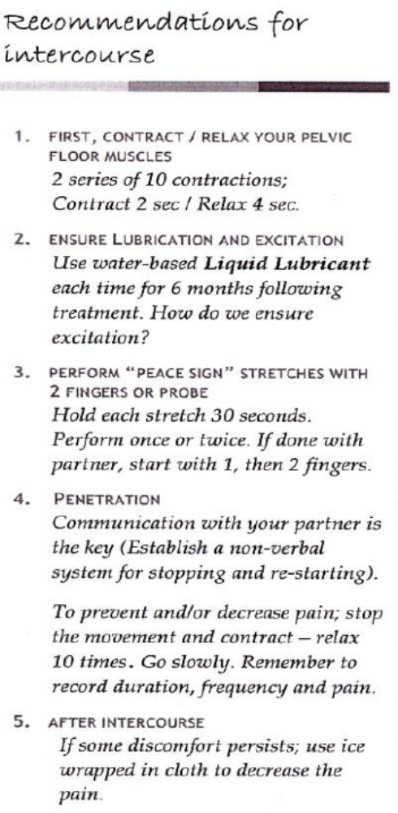

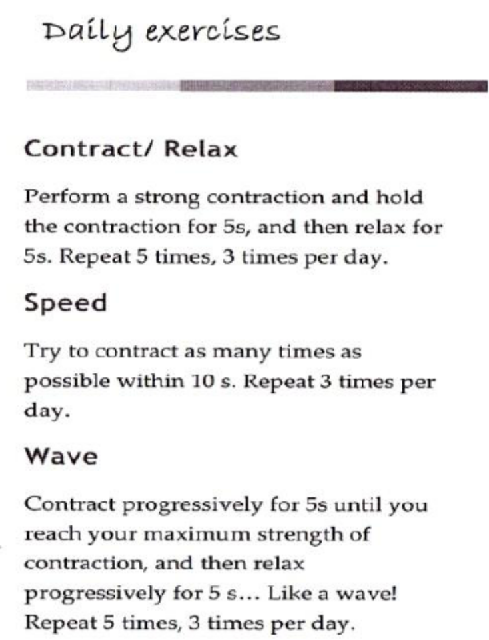

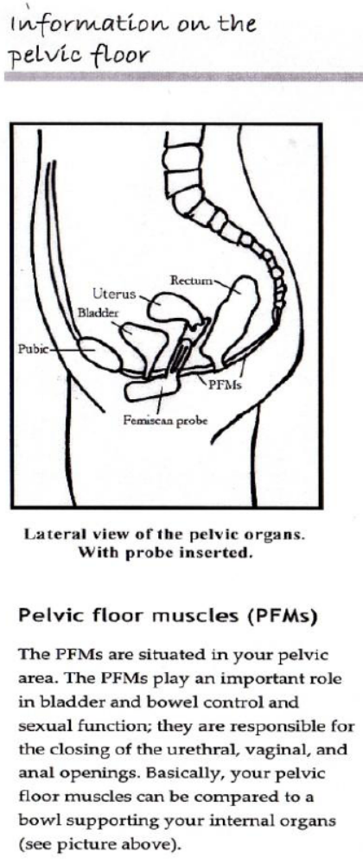

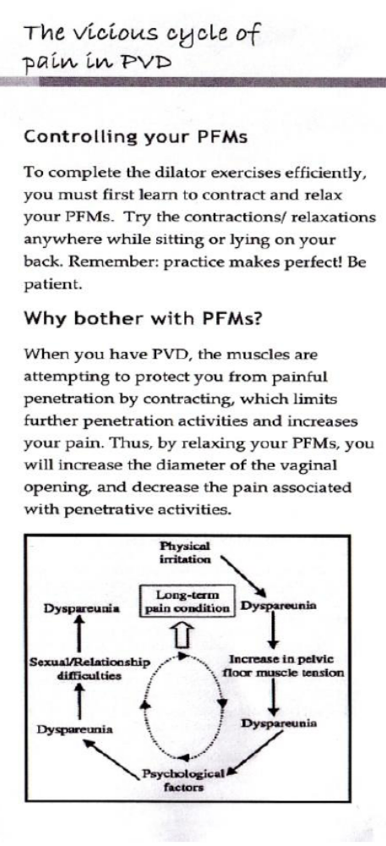

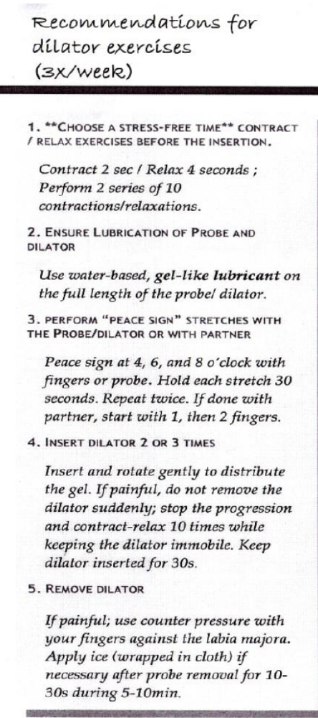

Dilator Exercises
What are dilation exercises?
Dilation exercises consist of the insertion of vaginal dilators of progressively larger sizes into your vagina, while your pelvic floor muscles are relaxed. The goal of the dilation exercises is to reduce the pain that you experience in the genital area. Dilation exercises reduce pain by helping you overcome the anxiety associated with painful penetration, and by relaxing the pelvic floor muscles and gradually stretching the vaginal opening. Dilation exercises are performed in combination with pelvic floor muscles contractions and relaxations, which means that you will perform contractions/relaxations of your pelvic floor before and during the dilator insertions, in order to further reduce the pain associated with penetration.
Are dilation exercises recommended for women who have genital pain?
Yes, dilation exercises have been recommended to women with many pelvic floor muscle problems, including genital pain and incontinence. Dilation exercises are commonly recommended by doctors, physiotherapists, and psychologists treating women with genital pain.
What are pelvic floor muscles (PFMs)?
The pelvic floor muscles (PFMs) are situated in your pelvic area. The PFMs play an important role in bladder and bowel control and sexual function; they are responsible for the closing of the urethral, vaginal, and anal openings. Basically, your pelvic floor muscles can be compared to a bowl supporting your internal organs (see picture below).

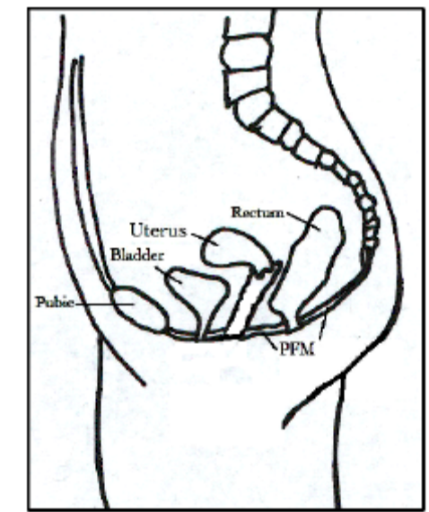

How do I perform a PFM contraction?
To complete the dilator therapy efficiently, you must first learn to contract and relax your PFMs. You can try those contractions/relaxations anywhere, since no one will be able to tell! You can perform the contractions/relaxations while sitting, lying on your back, or lying on your stomach. At the beginning, you may find the contractions difficult to perform, but remember: practice makes perfect! Be patient. It may take weeks before you feel comfortable with performing contractions and relaxations.
1. Sit or lie down comfortably with the muscles of your thighs, buttocks and abdomen relaxed.
2. Tighten the ring of muscle around the urethra and anus as if you are trying to control urine flow, diarrhoea, or wind. Hold the contraction for two seconds. Relax it.
3. Practice this movement several times until you are sure you are exercising the correct muscle. Try not to squeeze your buttocks or thighs.
4. If you are having trouble isolating the PFMs, when you are urinating, try to stop the flow mid-stream, and then restart it. Only do this to learn which muscles are the correct ones to use do not attempt to perform this exercise often, as it may interfere with normal bladder emptying. When you have identified your PFMs, you can start the dilator therapy.
Why should I do PFM contractions during the dilation exercises?
It is believed that when you have chronic vulvar pain, the muscles are attempting to protect you from painful penetration by contracting, which limits further penetration activities and increases your pain. Thus, by relaxing your PFMs, it is believed you will increase the diameter of the vaginal opening, in turn reducing the pain associated with penetrative activities.
How do I do the dilation exercises?
We suggest that you do the exercises in a relaxed environment when you have at least 30 uninterrupted minutes available. Start by getting in a comfortable position, such as half-sitting with your back supported by pillows, and with your knees bent. Perform two series of 10 pelvic floor muscles contractions, and focusing on relaxing your pelvic floor muscles at the end of each contraction. After having performed 20 contractions, apply lubricant on the dilator, ensuring that the dilator is covered with lubricant from top to bottom. Then, insert the dilator slowly and gently into the vagina. Use a mirror to guide you if necessary. Remember to take deep breaths and take your time.

If you feel pain and/or discomfort during the insertion, maintain the dilator immobile and perform pelvic floor contraction while the dilator is inserted. In doing so, focus on the relaxation part following the contraction, and try inserting the dilator further. You can insert the dilator as far into the vagina as it feels comfortable. Hold the dilator in the vagina for 2-3 minutes. Then, remove the dilator slowly. You will be provided with 3 dilators, one small, one medium, and one large, as well as some water-based gel-like lubricant. Start with slowly inserting the smallest dilator. When you feel ready to do so, and when the pain has decreased with the use of the small dilator; progress to the medium dilator and repeat the same exercises. Then, move on to the large-sized dilator when you feel ready and repeat the same exercises. The dilator insertions can be performed with your partner once you have become comfortable performing insertions by yourself. Simply instruct him/her on how to perform the insertions, and let him/her know when, how fast and how far to insert the dilator. The best way to do this is for you to get into a gynecological examination position with your knees bent and your back supported by pillows. Position yourself so that you are at the edge of a table or bed, so that your partner can comfortably maneuver the dilator. Remember to communicate with your partner throughout the exercises to let him/her know when to stop and re-start inserting the dilator. Most partners will be very concerned with provoking a painful reaction, and in turn, their involvement with the dilator therapy could be a good preliminary to eventual attempts at intercourse, by giving them a better understanding of your condition.
How many times and for how long should I do these exercises?
Dilation exercises should be performed 5 times a week. Each time you do the exercises; perform 2 or 3 insertions, depending on your level of comfort. If you have too much pain or discomfort, it is better to avoid exacerbating your symptoms, and to try again later. After each insertion, leave the dilator in the vagina for approximately 2-3 minutes to allow the stretch of the vagina to occur.

How do I clean the dilators?
The dilators can be cleaned with hand-soap and tap water. Soap might be irritable for the area at the entrance of the vagina (the vulvar vestibule), so rinse thoroughly, and dry with a towel. Roll the dilators in a dry towel to store them, and rinse them again before using them at the next exercise session.
When can I expect to see some improvement?
Dilator therapy can seem very invasive, uncomfortable and time-consuming. Keep in mind that for the treatment to take effect, it could some time and lots of practice as gaining tissue flexibility takes time to achieve. However, once it is achieved, you can expect to have to perform one insertion of the dilator 2-3 times a week to maintain what you have gained during treatment.
Some more tips
You may find using a dilator is more comfortable after a hot bath, which relaxes you, and makes your skin softer and more pliable. The easiest way to insert a dilator into the vagina is to lie down on a bed in a relaxed position, with your knees bent. However, much like tampons, some women prefer to insert them whilst standing with one leg on a chair. Please note that you should not develop buttock, thighs, back or abdominal pain while or after having performed the pelvic floor muscles contractions. If this occurs, you are probably performing the contractions too strenuously.

Each participant progressed through three vaginal dilators either with (La Sexérie, Montreal, QU, Canada) or without latex (Come as You Are, Toronto, ON, Canada)

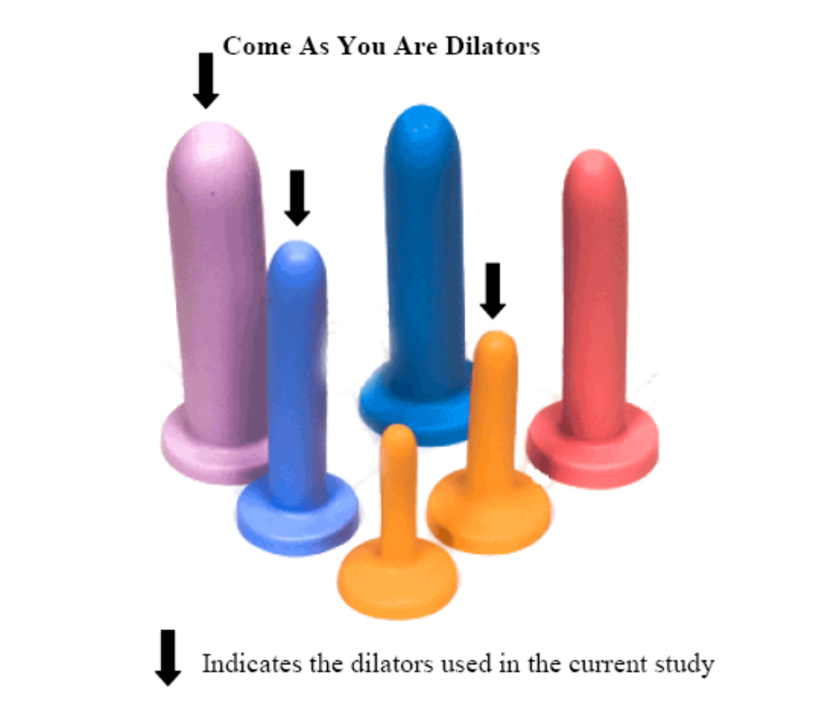

available here as a “Vaginal exercise set” for $150.
Syringe covers that are about the same sizes (a 20 ml and 60 ml cover for smaller two sizes anyway) cost nothing.

http://www.comeasyouare.com/index.cfm?fa=Catalog.Product&ProductId=2106

posted on their site:
I had incredible difficulty with vagina penetration. These things are great. I started with getting in a small OB tampoon and then moved up to Exerciser 1 and have progressed up to exerciser 4. They are easy to use, work well with water based lube and are so easy to clean and put away. The variety of sizes (diameter and lengths) help ensure that there is progression. For anyone that has difficulty with penetration, I would recommend you give these a shot.

http://www.lasexerie.com/ - no info though


